**Assignment Day 13 and 14**

**Question 1: Working with RDS**

Task 1: Create an RDS Database Instance

Ss1: Db instance page

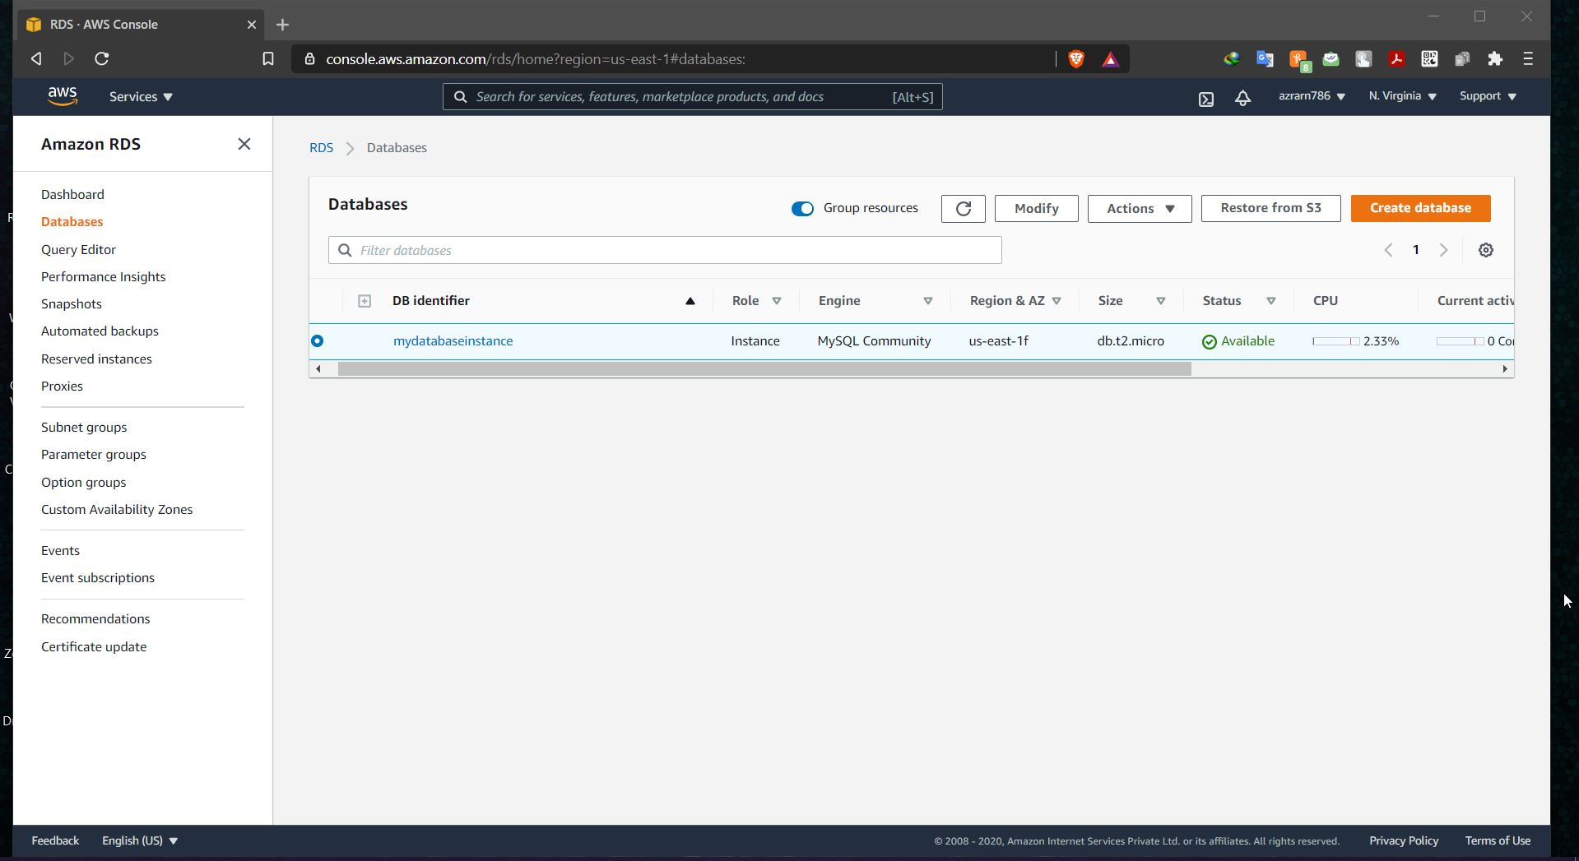

Ss2: DB instance details

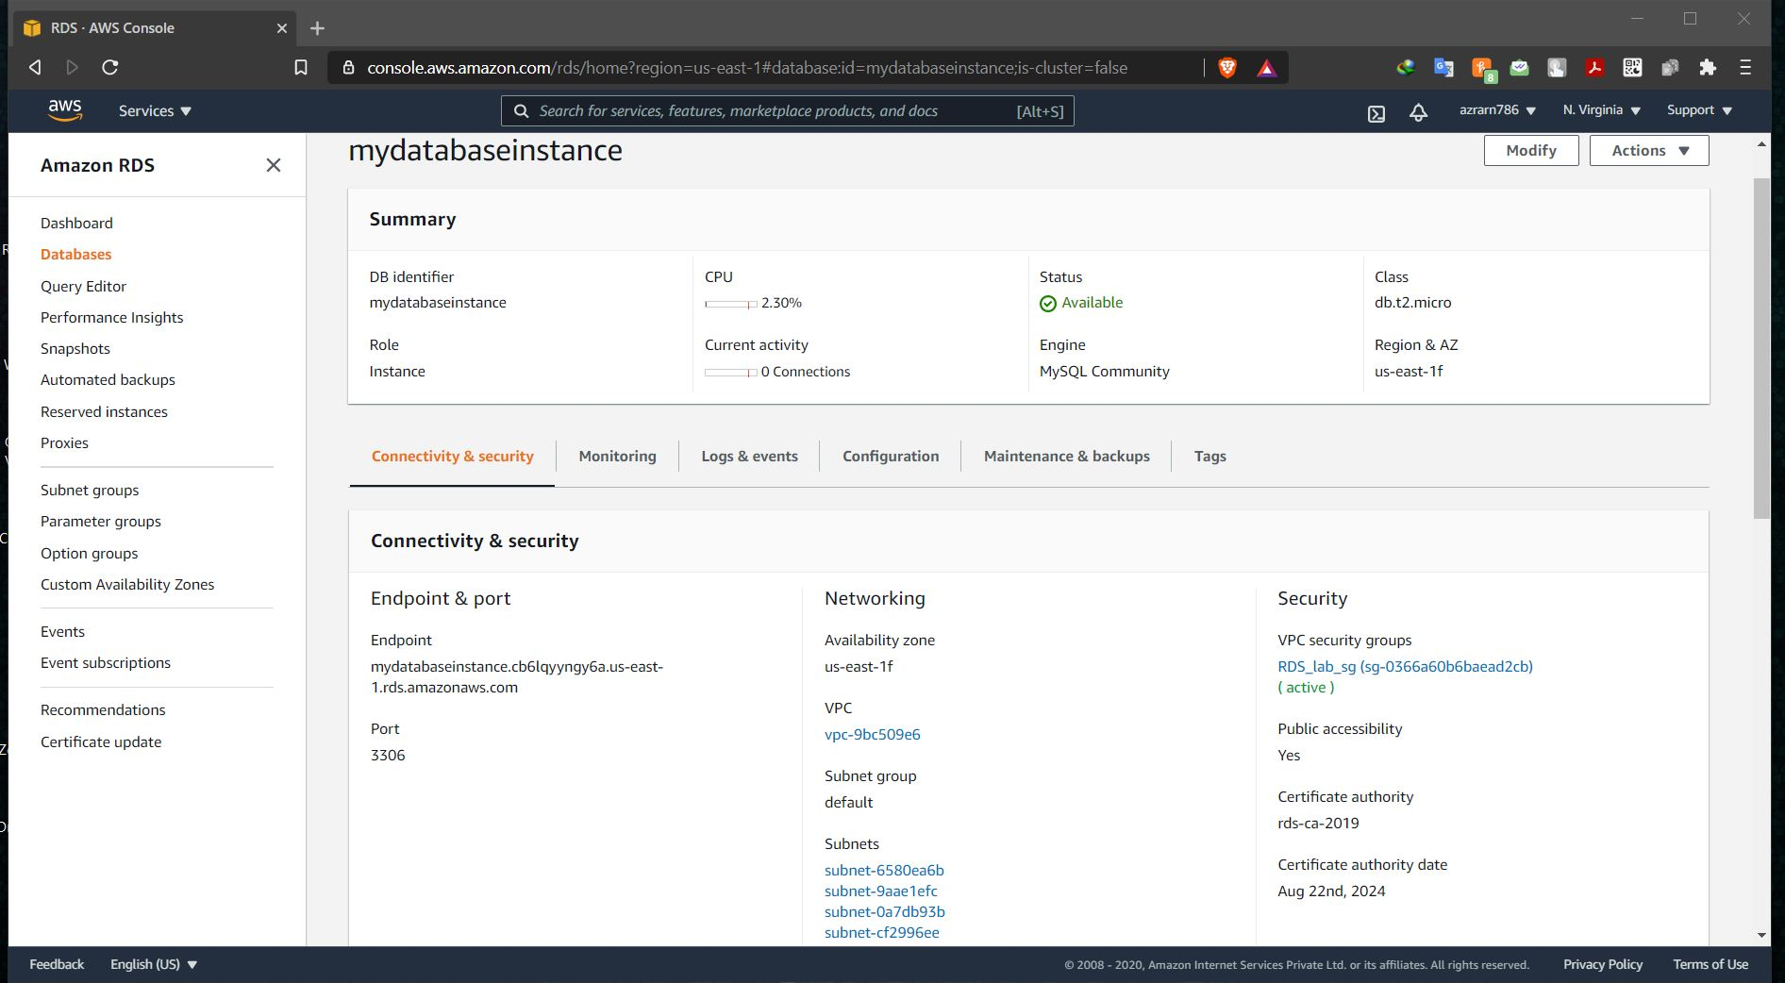

Ss3: security group inbound rules + multiple changes made to a security group

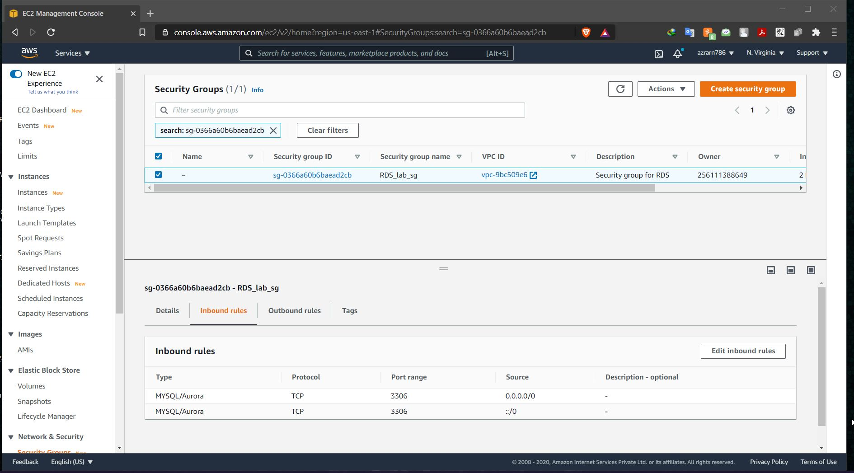

Ss4: sql workbench endpoint added

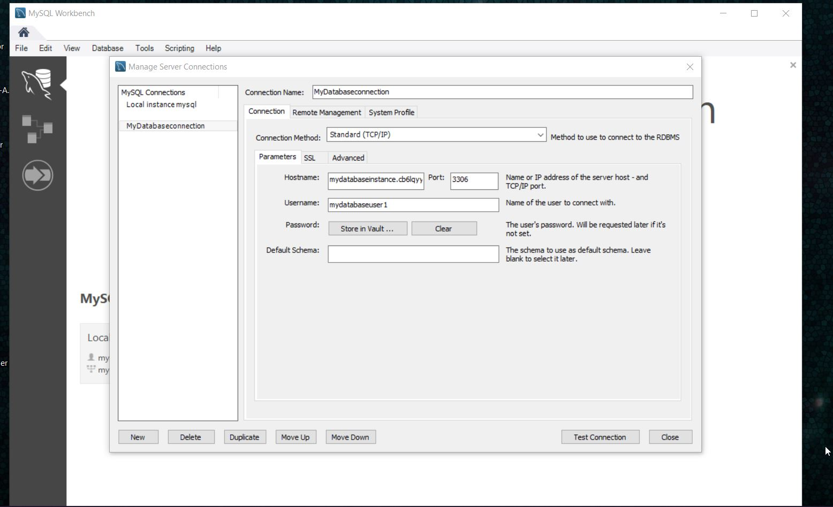

Ss5: secret vault entry

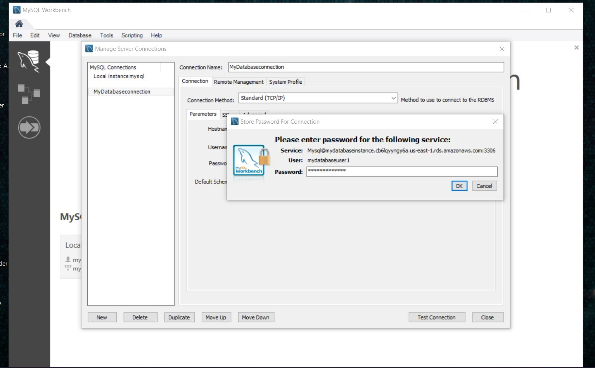

Ss6: confirm connectivity screen

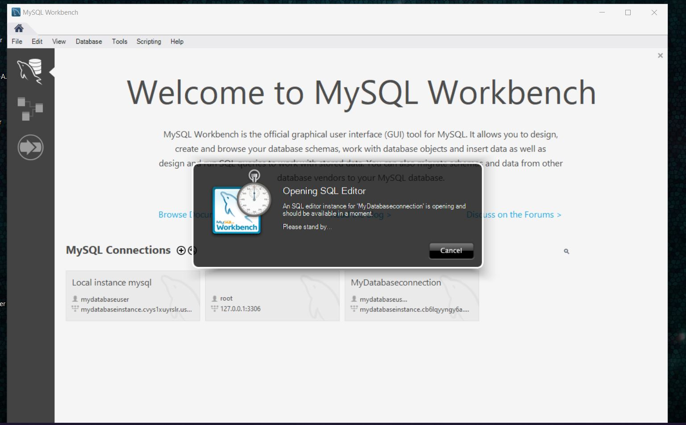

Task 2: Connecting to RDS Database on a DB Instance using the MySQL Workbench

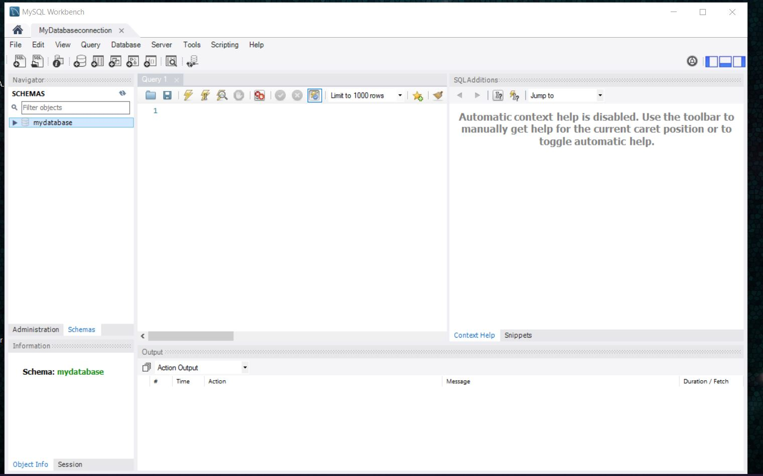

Task 3: Test Connection

